CHAPTER 3
CALCULATION OF LOADS & ANALYSIS

3.1 Types of loads:
1. Dead load
2. Live load
3. Wind load
4.Earth quake load
3.1.1 Dead load( DL):
Dead load is a permanent and stationary vertical load which is subjected to the structure mainly due to the self-weight of the structural components such as beams, slabs, columns and walls etc. it also includes the weight of permanently fixed equipment. The dead load acts on the structure throughout its life time.
The dead load can be calculated by multiplying the volume of the structural component and the unit weight of the material. The unit weights of the different materials are given in the IS 875 part-1 : 1987.
3.1.2 Live load (LL):
Live load also called as imposed load, these are the loads which are moving or movable without any acceleration or impact. These loads are subjected to the structure occupancy of the building including weights of movable partitions or furniture etc.
Live loads keep on changing from time to time. The minimum values of live loads to be assumed are given in IS 875 (part 2)–1987. It depends upon the intended use of the building.
3.1.3 Wind load:
These types of loads are imposed by the wind. The structure should be strong enough with the heavy dead weights and anchored to the ground to resist this wind load. If not, the building foundation may fail. Wind load acts horizontally towards roofs, walls and columns.
The specifications for wind loads are given in IS 875 part 3 : 1987,
As per National Building Code Structure of 15 m height and above is to be considered for wind load.
3.1.4 Earth quake load:
Earthquake forces constitute to both vertical and horizontal forces on the building. The total vibration caused by earthquake may be resolved into three mutually perpendicular directions, usually taken as vertical and two horizontal directions. The movement in vertical direction do not cause forces in superstructure to any significant extent. But the horizontal movement of the building at the time of earthquake is to be considered while designing.
As our plot is not in the earthquake prone area, we have not considered the earth quake loads in this project.
3.2 Load calculation on slab:
The slab is divided into smaller slabs resting on beams, each slab acts as the continuous slab. The loads on the slabs are calculated as follows:
3.2.1 Dead load calculation:
The dead load can be calculated by multiplying the volume of the structural component and the unit weight of the material used. The unit weights of the materials used,[which are taken from the IS 875 part-1 : 1987] are given below.
S. No | Materials | Unit weight KN/m³
1 | Reinforced cement concrete | 25
2 | Plain cement concrete | 24
3 | Common burnt clay Bricks | 15.7-18.85
Table 3.1: unit weight of the materials used.
Slab load:
The slab thickness is assumed as 125 mm.
Self-weight of the slab = 1 x 1 x 0.10 x 25
= 2.50 KN/m²
Weight of weathering course = 1 KN/m²

Dead Load = 3.5 KN/m²
______________________________________

Parapet load:
Self-weight of the parapet wall = 1 x 1 x 0.1 x 18
= 1.8 KN/m

Beam load:
Self-weight of the beam = 1 x 0.23 x 0.3 x 25
= 1.725 KN/m

Wall load:
Self-weight of the 9” wall = 1 x 0.23 x 2.7 x 18= 11.18 KN/m
Self-weight of the 4” wall = 1 x 0.10 x 2.7 x 18= 4.86 KN/m
3.2.2 Live load calculation:
Live load on roof slab:
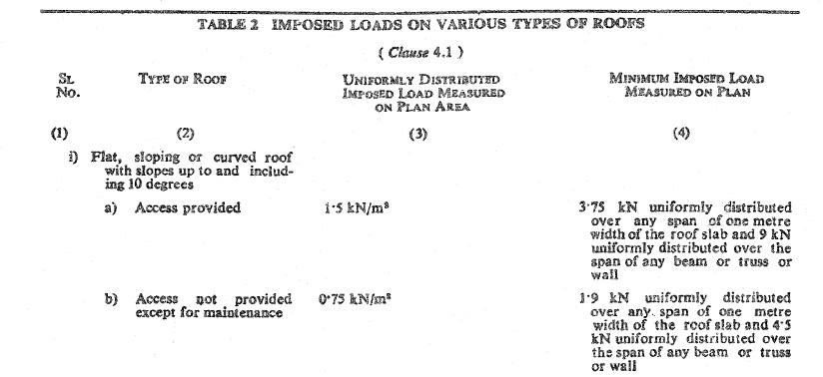
The live load on roof [which is given in IS 875 part 2 -1987, page No. 14, table No. 2] is shown in figure 3.1.
Figure 3.1: Imposed load on roof.
The imposed load on the roof slab is taken as 1.5 KN /m² because the access is provided to the roofs.
Live Load on floor slab:
Live load on floor slab based on occupancy is shown in figure 3.2. [which is given in IS 875 part 2 -1987, page No. 7, table No. 1].
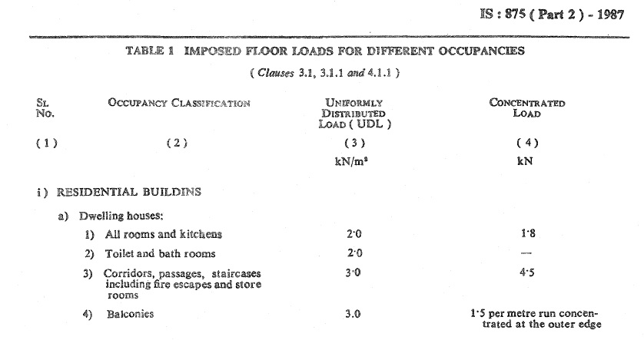
Figure 3.2: Imposed load on floor slabs.
The imposed load on the floor slab is taken as 2 KN /m² for all rooms & kitchen and for corridors & balconies the load is taken as 3KN/m².
3.3 Load distribution from slab to beams:
Load is distributed in beams based on type of slab (according to ly/lx ratio).
Type of slab based on ly/lx ratio:
One-way slab: if the ly/lx ratio of the slab is greater than or equal to 2 then the slab is considered as one-way slab.
two-way slab: if the ly/lx ratio of the slab is less than 2 then the slab is considered as two-way slab.
Where,
ly = longer span of the slab
lx = shorter span of the slab
In case of one-way slab, the loads are distributed evenly on both longer sides of slab in the form of rectangles which can be calculated by multiplying load and the area of rectangle.
In case of two-way slab, the loads are distributed to the beams in the form of triangles and trapezoids. The following formulas are used to calculate the distributed loads on beans.
For triangle - $\frac{wl_{x}}{3}$
For trapezoid - $\frac{wl_{x}}{2} (1-\frac{1}{3β^{2}})$
Where,
$β= \frac{l_{y}}{l_{x}}$
The following figures show the loads distributed from roof slab and floor slab to the beams.

